Hey Allan,

I really love your design, I’m a big fan of the full page design with the centered heading. The parallax images are also really beautiful when scrolling down the page. One suggestion right off the bat is to maybe make the text in the triangles a bit bigger

.triangle-text font-size 1.5rem looked a lot better for me

With the fullpage design the button to go back to the top of the page is nice, but I’m not really a big fan of it being so far out, personally i think it would look better in the bottom right corner

.back-to-top right 10px and bottom 10px made it feel less in the way

Your design is really solid and looks great throughout the website.

For your hobbies page it looks like the text on the triangles are white, and its really hard to read so maybe change the color to black.

Since the design is fullpage I think that the navbar should follow the user so that you can go to the next page without having to go back to the top, though the button is there for it.

For your .nav-container i changed the position to fixed and it follows when scrolling. (if you do this you might want to add a background to the nav so the images dont block the white color.)

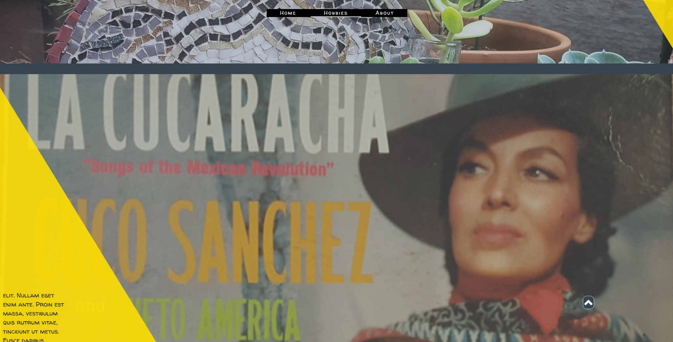

I really like the about page, very simple and clean, I would suggest to do an overflow-y: hidden as the page is just the single section, I hate it when there are scroll bars for things that are already in the viewport.

Before:

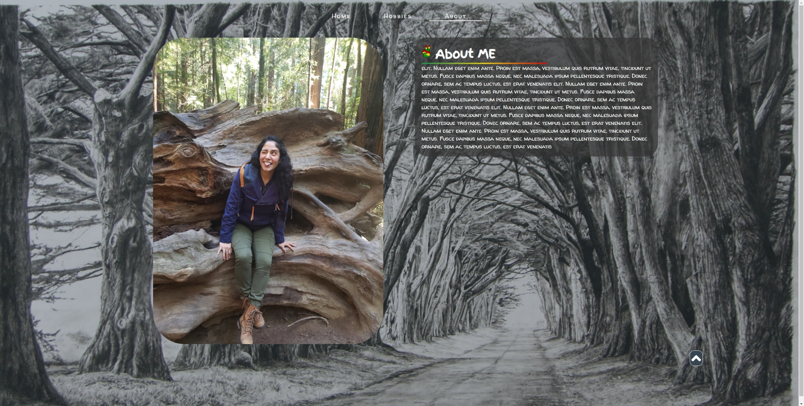

After:

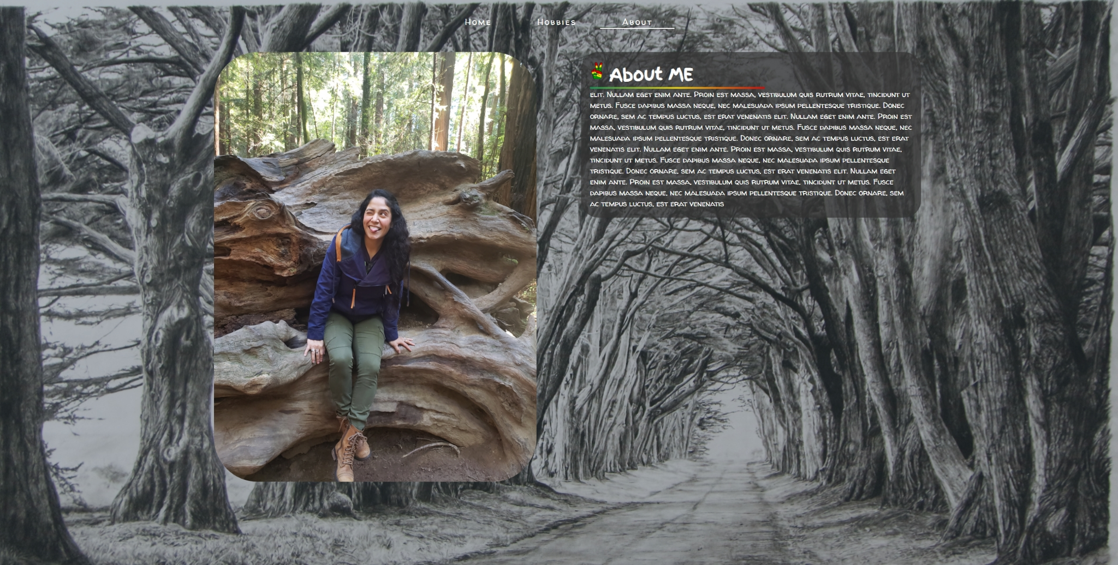

(i also removed the back to top button as it isn't needed on this page :) )

Keep up the good design!